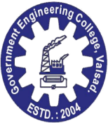 | 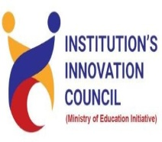 |  | 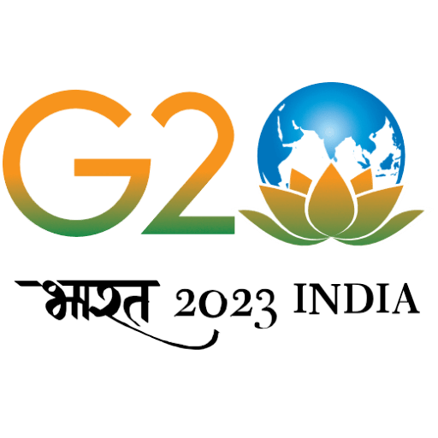 | 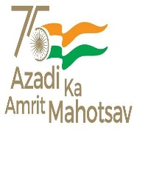

GOVERNMENT ENGINEERING COLLEGE, VALSAD

Report

on

Coastal Cleaning Day Celebration

16-09-2023

About the Event:

On 16th September 2023 international coastal cleaning day was celebrated at Tithal beach Valsad by Trayam foundation headed by Dr Bhairavi Joshi , Khusbu Madam and equally well supported by colleges of Tithal Valsad, including government Engineering College Valsad. The beach cleaning activity begun with inaugural speech of honorable Dist Collector, Valsad Smt. Shipra Agre Madam. Dr K L Mokariya gave brief about how the beach cleaning activity will take place, procedure and safety measures to be taken The waste was segregated in terms of plastic and non-plastic waste and after measurement plastic waste was sent to Atul Ltd Valsad. All the students’ participants were given certificate of participation by Trayam foundation Valsad.

Innovations on environment and power generation by tidal energy was discussed on site.

Total 318 kg waste collected from beach out of which 190 KG was from GECV group of students and faculty.

Participants Detail:

